**Code Inspection**

**Reviewer**: Minsoo Park

**The code under review:**

This is a UI bug found in the zoteroEXT.js

**The date of the review:**

November 9, 2015

**The name of the author of the code under review:**

Nadeem Haidar

**Bug:**

In the Edit tag tab from our UI window, there was a limit of maximum length in the textbox.

So the tags were not shown after the maximum length.

Because Nadeem was using ‘richlistitem’, tags were not shown after the maximum length set by ‘richlistitem’.

**How to reproduce:**

1. Create a long-tag in Zotero.
2. Launch ZoteroEXT
3. Go to ‘Edit tag’ tab and you will see the tag is not fully displayed.

**The location of the bug:**

Line 62, 67 and 71 in chrome/content/zoteroEXTended/zoteroEXT.js

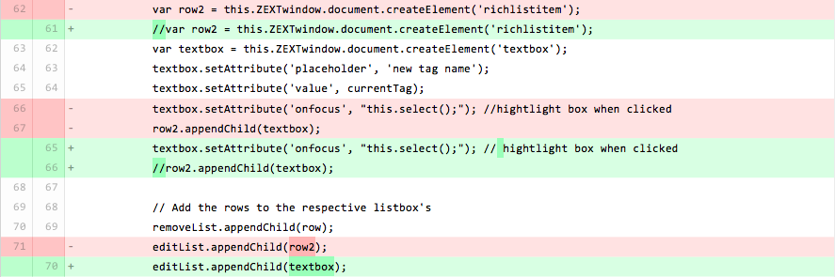

**Suggestion for fix:**

Simply changed the ‘richlistitem’ to ‘textbox’ so it does not have the limit on the length.

**Missing documentation:**

Overall, our codes do not have well documentation. And also the code that I inspected does not have documentation. But we will have some time on documentation.

**Poor testing:**

We have not made our test cases yet.